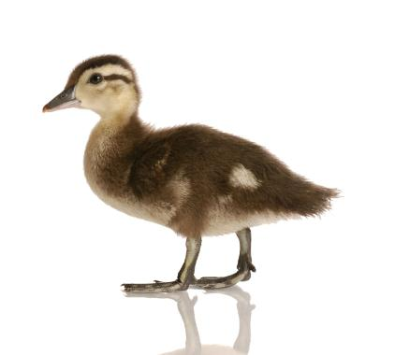
Sun | Mon | Tue | Wed | Thu | Fri | Sat
 |  |  |  | 1  Parts of the Flower | 2  Hand Flowers | 3
4 | 5  Secret Craft Week (Shhh) | 6  Book: Just Me and My Mom | 7  Animal Families | 8  “M-O-M-M-Y” | 9  Don’t Forgot to Tell Your Mom You Love Her! | 10
11 | 12  Book: The Grouchy Ladybug | 13  Hungry Caterpillar | 14  The Life Cycle of a Butterfly | 15  Butterfly Match | 16  “Hunting Bugs” | 17
18 | 19  Victoria Day  Daycare Closed | 20  Frog Puppet | 21  “Five Green and Speckled Frogs” | 22  Book: The Big Wide Mouthed Frog | 23  Musical Lily Pads | 24
25 | 26  “Climb Aboard the Spaceship” | 27  Rocket Blast Off Size Sequencing | 28  Book: There’s No Place Like Space | 29  Our Solar System | 30  Making Constellations | 31

May
Theme:
Mother’s Day

Theme:
Frogs

Theme:
Bugs

Theme:
Garden

Waddling Duck Daycare
Come Quack it up!

939 Griffith Street, London, ON N6K 3S2
Phone: 226-663-1828
Email: waddlingduckdaycare@rogers.com

$ Fees Due $
for week of 12th
$ Fees Due $
for week of 19th
$ Fees Due $
for week of 26th
2014
$ Fees Due $
for week of 5th

Theme:
Space

Mother’s Day
Happy 3rd
Birthday Carter!
Happy 2nd Birthday Elliott!

$ Fees Due $
for week of 2nd

