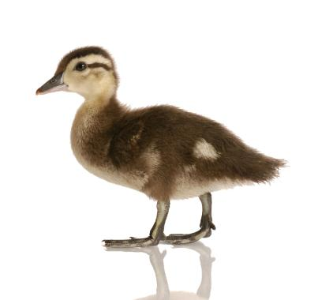
Waddling Duck Daycare
Come Quack it up!

939 Griffith Street, London, ON N6K 3S2
Phone: 226-663-1828
Email: waddlingduckdaycare@rogers.com
Sun | Mon | Tue | Wed | Thu | Fri | Sat
 |  |  | 1  Special Shape Snacks | 2  Shape Elephant | 3  “Our Shapes” | 4
5 | 6  Book: Thanksgiving is for Giving Thanks | 7  Turkey Feather Counting | 8  “Funny Bird” | 9  Thanksgiving Turkey | 10  The Turkey Walk | 11
12 | 13  Closed to Celebrate  Thanksgiving | 14  “I’m a Little Scarecrow” | 15  Making a Scarecrow | 16  Book: The Scarecrows Hat | 17  The Scarecrow  Match-up | 18
19 | 20  Field Trip:  Pumpkin Picking  9:30 – 11:30am | 21  Pumpkin Painting | 22  Pajama Day: Don’t forget to wear your PJ’s!  Bronwyn is 3! | 23  Pumpkin Carving | 24  Book: The Berenstain Bears Trick or Treat | 25  Brynn is 1!
26 | 27  A Little Batty | 28  Ghostly Feet | 29  “Trick or Treaters” | 30  What’s Missing on My Jack-o-Lantern? | 31  Halloween Party!  Wear Your Costumes!

October
Theme:
Thanksgiving

Theme:
Halloween

Theme:
Scarecrows

$ Fees Due $
for week of 6th
$ Fees Due $
for week of 13th
$ Fees Due $
for week of 20th
2014
Theme:
Halloween

$ Fees Due $
for week of 27th

Theme:
Shapes

$ Fees Due $
for week of 3rd

